Phase 4: Beta Release: Environment sustainability: study the impact of air pollution
Introduction
Although many of us are aware of the most common pollution causing factors that is harming the air we breathe and the atmosphere, there is a room for identifying some of the new and uncommon pollutants and their level of impact on the mother nature. For example, CFCs and the methane gas produced by animal husbandry in various economies depleted the ozone layer considerably in past few decades. In this project such causes along with other common causes will be highlighted and the impact will be studied.

Objective
The study intends to help the user to visualize the increase and decrease of air pollution level and its causes at various parts of the world over a period of time.

Dataset
The data has been taken from https://www.airnowtech.org/data/. The dataset contains various levels of pollutants in air for various areas in Maryland.
Other source of data is https://mde.state.md.us/programs/Air/AirQualityMonitoring/Documents/MDNetworkPlanCY2020.pdf to plot the latitudes and longitudes of the sites on the world map using geo scatter bubble plot.

Prototype

Figure 1: Global map and popup window to select the region of study
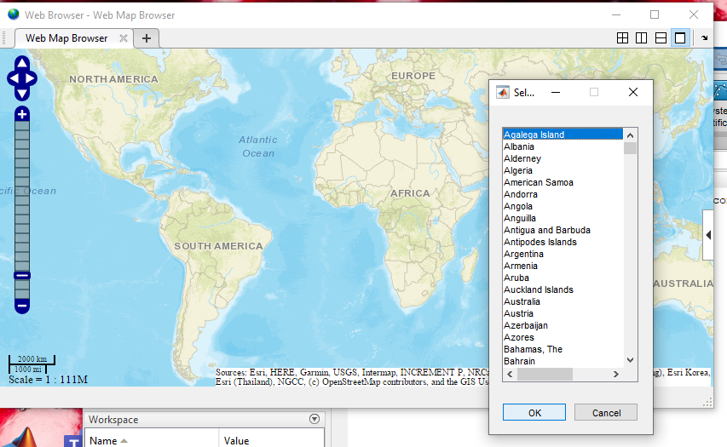

Figure 2: Reference scale of cloud cover percent
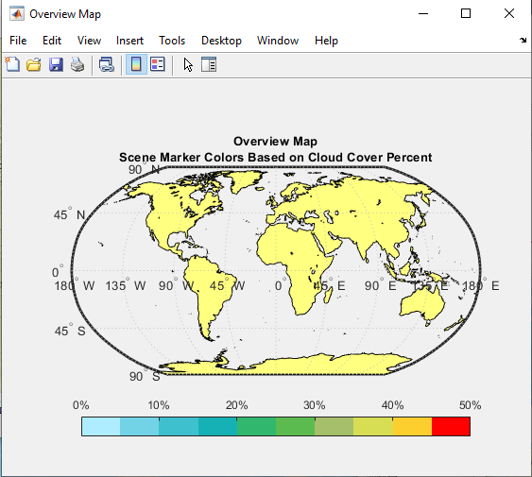

The two sites Edgewood and Essex are taken into consideration to study impact of air pollution. The contents of air like oxygen level, methane, carbon monoxide etc. are taken from data and the average is derived across a period and plotted on geo scatter plot. The study approaches the implementation as follows:
Interface 1: This is achieved using MATLAB base map. Each region is highlighted with the following details:
- Latitude and longitude points for the site has been first bubble plotted on the base map.
- Concentration of pollutants like methane, carbon monoxide is plotted in map and the scale varied from green to red based on the increasing level of pollutants at the region.

Figure 3: Each marker represents various data attributes for that region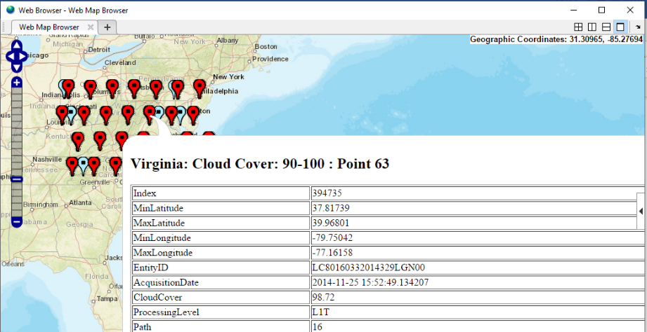

Click event on the map points will lead to a new window – interface 2.
Bugs: The data currently used is not the actual data from the source and a dummy data has been plotted. The data from the source will be filtered and plotted in a similar way.

Interface 2: Clicking on the region node will open a new interface representing pollution level of that region across (say 5) decades. An animated plot based on time series data will be included and research about pollution related activities in the area will be covered in interface 3.
Enhancement - the activities affecting the pollution levels depending upon the data we have. If the level reduces over a range, we also intend to include data about the measures taken in that region. We are planning to develop interface 2 in VR or Unity or Animated mode.

Interface 3:

This interface would have a the option to compare 2 different sites, based on concentrations of specific pollutants. Different plots would be juxtaposed to contrast on the differences. It is an animated plot, with time series data.

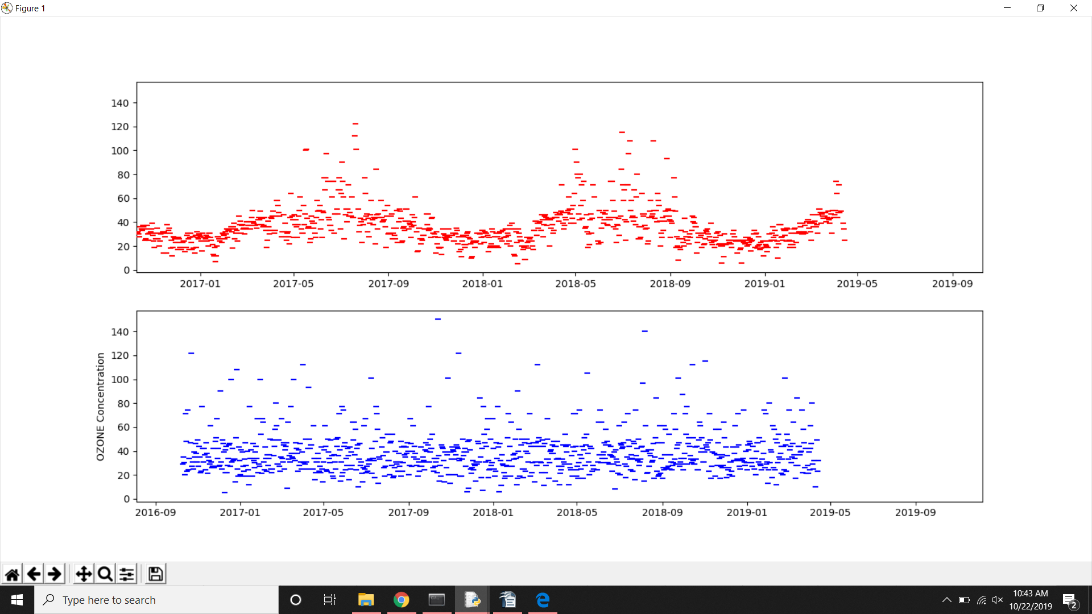
Bugs :
- Animation not working with lineplot.

Enhancements :

  - Making it interactive, and make the datapoints clickable through the plot.
  - Visualizing data for a longer time period.

References:

• Dua, D. and Graff, C. (2019). UCI Machine Learning Repository
[http://archive.ics.uci.edu/ml]. Irvine, CA: University of California, School of Information
and Computer Science.
-UCI machine learning repository is a data repository that provides data across various
domains. The website has been referred to collect and study different datasets suitable to
implement and test visualization tools to be used for this project.
• https://www.mathworks.com/
-To choose the visualization technology, various tools were studied and the most suitable
approach based on requirement of type of data was considered. The website has been
referred to learn and implement MATLAB tool for testing purpose. Various set of
geospatial data was plotted using MATLAB to conclude the selectivity of the tool for this
project. Matlab is a matrix-based framework built exclusively for data science and
machine learning. With Matlab we can analyse data, develop algorithms, perform
operations like signal, image and video processing, control systems, test and
measurement, work on data like computational finance, and computational biology,
geospatial data.

• S. De Vito, E. Massera, M. Piga, L. Martinotto, G. Di Francia, On field calibration of an
electronic nose for benzene estimation in an urban pollution monitoring scenario, Sensors
and Actuators B: Chemical, Volume 129, Issue 2, 22 February 2008, Pages 750-757,
ISSN 0925-4005.
- The paper was referred to use the dataset for research on air pollution across various
regions and the content of chemical gases that pollute the air. “On field calibration of an
electronic nose for benzene estimation in urban pollution monitoring scenario” lists down
data from about nine thousand cases captured by chemical sensors. The data was
collected in one of the polluted regions in Italy during the year 2004 and 2005. The
dataser depicts CO, Hydrocarbons, Benzene, Total Nitrogen Oxides (NOx) and Nitrogen
Dioxide (NO2) content in air.
• https://public.tableau.com/en-us/s/
-The website was referred to try out another visualization Tool Tableau Public to
investigate if the tool can be fit for this project. With Tableau Public, the data can be
represented as charts, graphs, maps, and dashboards. Tableau Public is only supported
for excel workbooks and text files, data sources like SQL database cannot be directly
connected to Tableau Public. Tableau restricts us from performing computational
programming and building algorithms and therefore the tool is not selected for this
project.
• J. D. Hunter, "Matplotlib: A 2D Graphics Environment", Computing in Science &
Engineering, vol. 9, no. 3, pp. 90-95, 2007
- Matplotlib is a Python 2D plotting library which produces publication quality figures in a
variety of hardcopy formats and interactive environments across platforms. Matplotlib can
be used in Python scripts, the Python and IPython shells, the Jupyter notebook, web
application servers, and graphical user interface toolkits.
• Chen, P. J Image Video Proc. (2019) 2019: 42. https://doi.org/10.1186/s13640-019-0443-6
- Taking the work done by Chen in real-time monitoring data of 23 observation points
throughout Beijing to visualize the monitoring data in Google Earth, we can better understand
the requirement and effect of visualizations in the environmental pollution domain. Users can
understand the air quality distribution from a macro perspective or obtain the specific air
quality data by the interactive query to understand the time trends of air pollution, pollutants,
and air quality levels in different regions at different times. The approach selected by Chen is
a little different from us in terms of visualizing idiom, but the task and data abstraction has
provided us with a new perspective of the data.

